**Module 6 Assignment**

**Problem Statement:**

You work as a Power BI developer in leading Software Company. As a BI Professional, you have been asked to create a Dashboard on the Microsoft Power BI Portal, so managers can use this to bring data together in one place

**You have been asked to:**

1. Publish the Report Created in the Assignment 5 to the Power BI Service.

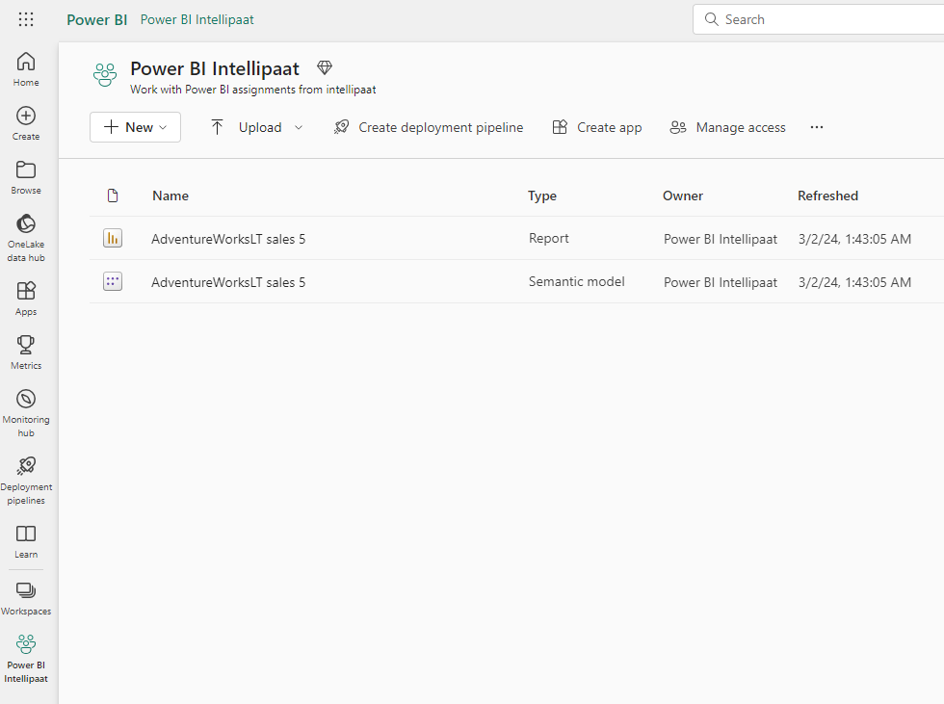

1. Create a new dashboard called Sales

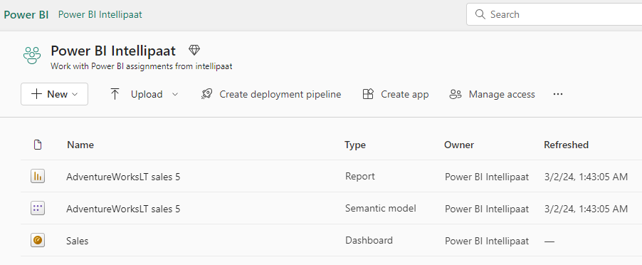

3. Pin Target Sales, Top Selling Customers, Orders by Main Category, Top Selling Bikes, Sales by Main Category visuals to the Sales Dashboard

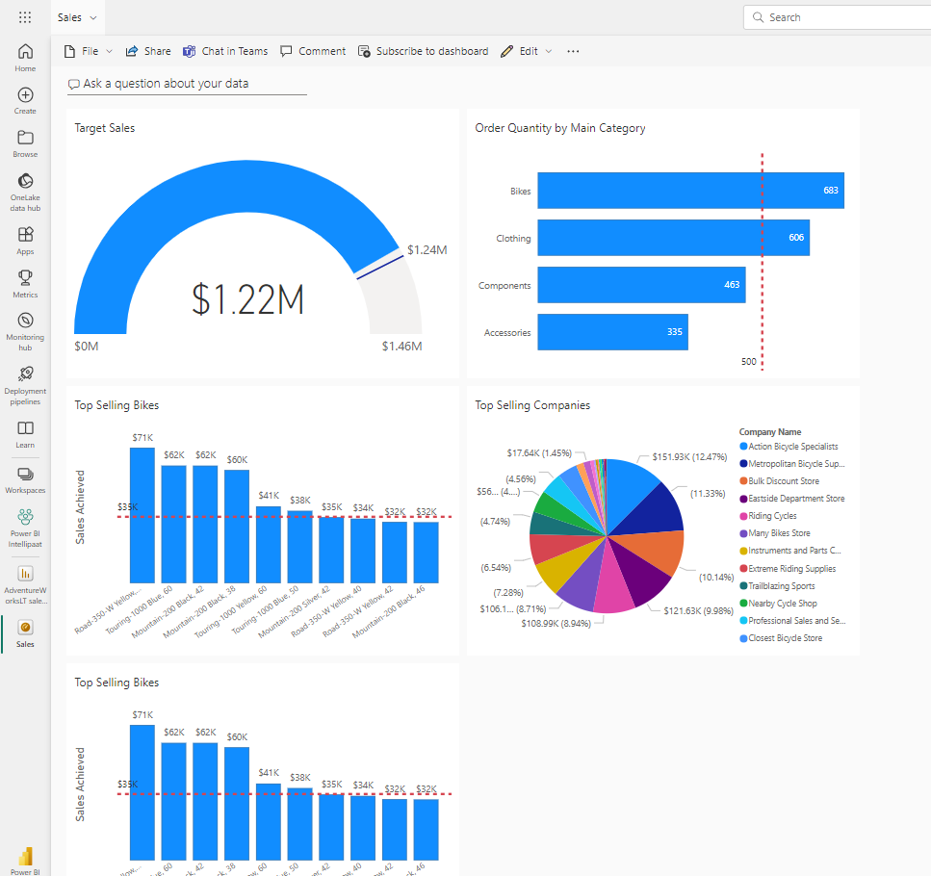

4. Open Sales Dashboard, Add a subtitle as Sales Target for 2020 under Target Sales Visual

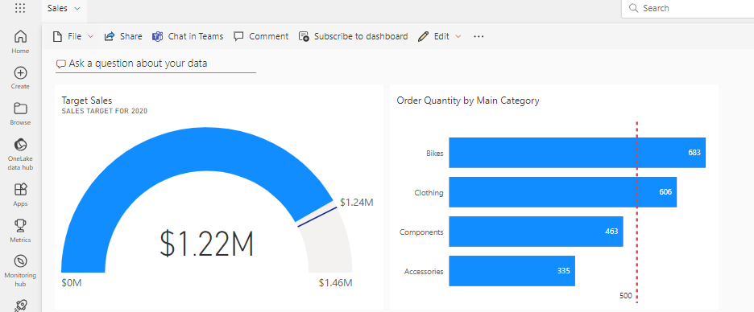

5. Open the Top selling bikes in Focus Mode and change the Line Total is greater than 32000 to 40000 and Exit Focus Mode

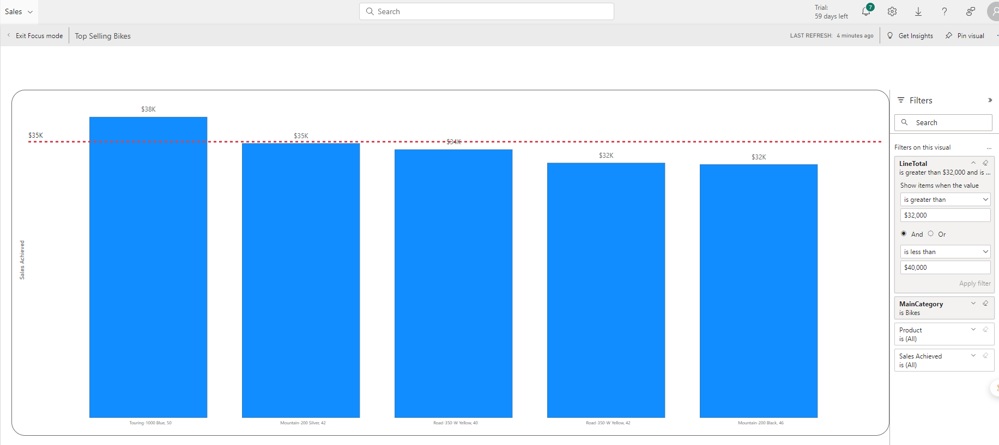

6. Use Q&A feature to find out the top country regions by Target Sales and use Pie Chart to visualize it

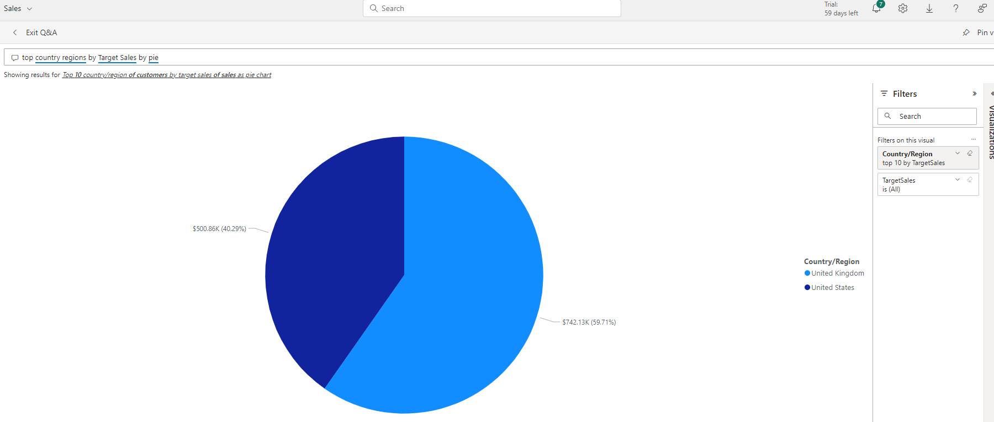

7. Pin that visual to the Sales Dashboard

